J. Kno.Mana.App.Pra. 1, No. 1,(2019) 1
Journal of Knowledge Management Application and Practice
An International Journal

http://dx.doi.org/10.18576/jkmap/010101

Title of the Paper (Font 18, can be reduced to lower the number of lines)
Author 1^{1,2}Author 2^{1,*} and Author 3².
¹ Affliction of Author.
² Affliction of Author.
Received: 21 Feb. 2015, Revised: 22 Mar. 2015, Accepted: 24 Mar. 2015.
Published online: 1 May 2015.

Abstract: This is the abstract; usually it does not have references. Usually the reader will read this part first to know what this paper is about and decide upon it to continue reading or not. The font of main text is 10 Times New Roman with single line spacing of 6 pt after and 0 pt before. The titles of sections are font 12, bold and they have single line spacing of 6pt before, 12 pt after, subsections are font 12, Italic and they have single line spacing of 6pt before, 12 pt after.
Both upper line and lower line enclosing this part is paper-specific and changes according to the paper, usually it is very similar to the journal header background color, abstract contents are Times New Roman size 10, no line spacing.
Keywords:

1 Introduction
Microsoft word has been used widely in writing scientific papers, LaTeX also has been widely used to generate a PDF and offers flexibility, very organized equations and elegant styles [1].
Microsoft word has been used widely in writing scientific papers, LaTeX also has been widely used to generate a PDF and offers flexibility, very organized equations and elegant styles [2,3].
Microsoft word has been used widely in writing scientific papers, LaTeX also has been widely used to generate a PDF and offers flexibility, very organized equations and elegant styles [5,6].
However, Microsoft word has been used widely in writing scientific papers, LaTeX also has been widely used to generate a PDF and offers flexibility, very organized equations and elegant styles [7,8]Microsoft word has been used widely in writing scientific papers, LaTeX also has been widely used to generate a PDF and offers flexibility, very organized equations and elegant styles [9,10] Microsoft word has been used widely in writing scientific papers, LaTeX also has been widely used to generate a PDF and offers flexibility, very organized equations and elegant styles [11,12]
2 Experimental Sections
2.1 Materials
The starting material is a computer, an internet connection, and large quantity of time and coffee.However, Microsoft word has been used widely in writing scientific papers, LaTeX also has been widely used to generate a PDF and offers flexibility, very organized equations and elegant styles [7,8]Microsoft word has been used widely in writing scientific papers, LaTeX also has been widely used to generate a PDF and offers flexibility, very organized equations and elegant styles [9,10] Microsoft word has been used widely in writing scientific papers, LaTeX also has been widely used to generate a PDF and offers flexibility, very organized equations and elegant styles [11,12]
However, Microsoft word has been used widely in writing scientific papers, LaTeX also has been widely used to generate a PDF and offers flexibility, very organized equations and elegant styles [7,8]Microsoft word has been used widely in writing scientific papers, LaTeX also has been widely used to generate a PDF and offers flexibility, very organized equations and elegant styles [9,10] Microsoft word has been used widely in writing scientific papers, LaTeX also has been widely used to generate a PDF and offers flexibility, very organized equations and elegant styles [11,12]
  - Deposition Method of Microsoft word
Microsoft word has been invented by Microsoft in Microsoft city by Microsoft employee.
Table 1. Percentages of solutions for sample preparation
 | Solution  (%) | Coffee  (%) | Sugar  (%)
Turkish | 75.00 | 15.00 | 15.00
Cappuccino | 80.00 | 10.00 | 10.00
American | 95.00 | 2.50 | 2.50
3 Results and Discussion
3.1 Structural and Micro-structural Analysis of Word
Structural and Micro-structural Analysis of word, Structural and Micro-structural Analysis of word
Structural and Micro-structural Analysis of word
Structural and Micro-structural Analysis of word
Paper=$\frac{Time }{Coffee X θ }$(1)
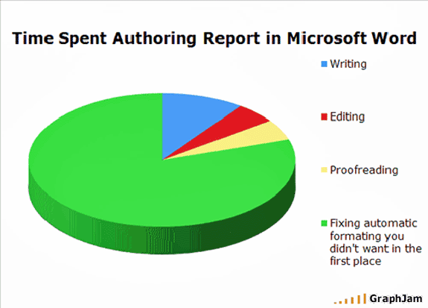
Figure 1.Micro-structural Analysis of time on word.
Temperature variation can cause slowness of completing a paper on word, using an air conditional or a fan is recommended.
3.2 Keyboard Analysis
However, Microsoft word has been used widely in writing scientific papers, LaTeX also has been widely used to generate a PDF and offers flexibility, very organized equations and elegant stylesMicrosoft word has been used widely in writing scientific papers, LaTeX also has been widely used to generate a PDF and offers flexibility, very organized equations and elegant styles Microsoft word has been used widely in writing scientific papers, LaTeX also has been widely used to generate a PDF and offers flexibility, very organized equations and elegant styles
4 Conclusions
In summary, we demonstrate why Microsoft Word is useful, the font of main text is 10 Times New Roman with single line spacing of 6 pt after and 0 pt before.
The titles are font 12, bold and they have single line spacing of 6pt before, 12 pt after.
Acknowledgement
The authors thankfully acknowledge Microsoft.
References
[1] B. Gates, Why word is used, Microsoft Lett., 69 (5), 53-60, 1998.
[2] B. Gates, Why word is used, Microsoft Lett., 69 (5), 53-60, 1998.
[3] B. Gates, Why word is used, Microsoft Lett., 69 (5), 53-60, 1998.
[4] B. Gates, Why word is used, Microsoft Lett., 69 (5), 53-60, 1998.
[5] B. Gates, Why word is used, Microsoft Lett., 69 (5), 53-60, 1998.
[6] B. Gates, Why word is used, Microsoft Lett., 69 (5), 53-60, 1998.
[7] B. Gates, Why word is used, Microsoft Lett., 69 (5), 53-60, 1998.
[8] B. Gates, Why word is used, Microsoft Lett., 69 (5), 53-60, 1998.
[9] B. Gates, Why word is used, Microsoft Lett., 69 (5), 53-60, 1998.B. Gates, Why word is used, Microsoft Lett., 69 (5), 53-60, 1998.

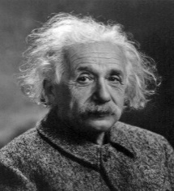 | Albert Einstein, the most influential physicist of the 20th century, with his work also having a major impact on the development of atomic energy. With a focus on unified field theory. Einstein took on a position at the Institute for Advanced Study at
Princeton, New Jersey and never went back to his native land.

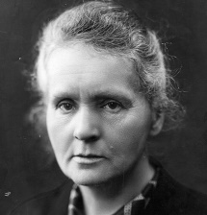 | Marie Curie, her work focused on radioactivity. With first female to win a Nobel Prize, Curie developed an international reputation for her scientific efforts, and she used her prize money to continue her research.
Curie received another great honor in 1911, winning her second Nobel Prize, this time in chemistry. She was selected for her discovery of radium and polonium, and became the first scientist to win two Nobel Prizes.

